**Name: E. Sai Manoj Mis. No.: 112015044**

**Code:**

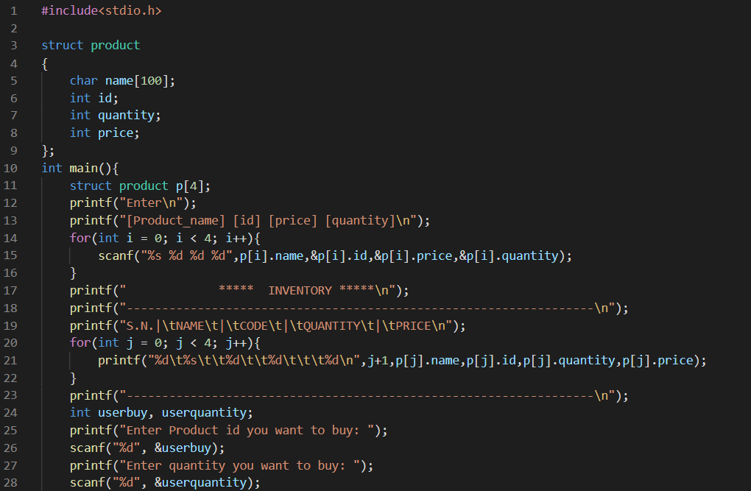

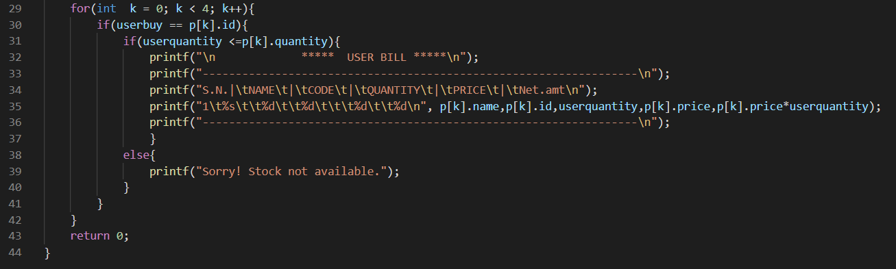

**Output:**

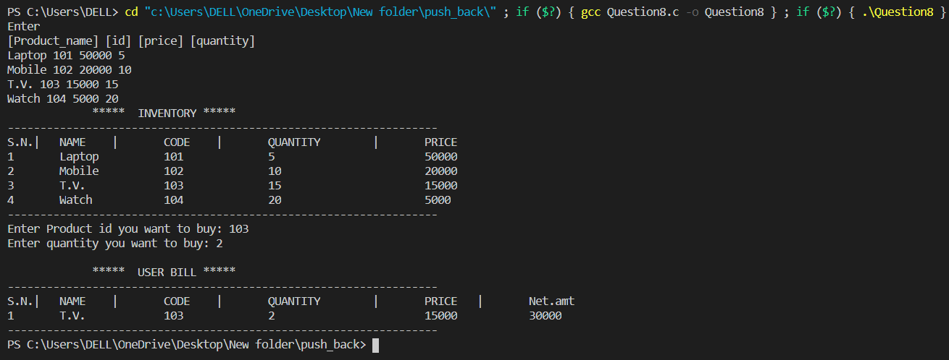

**Code:**

#include<stdio.h>

struct product

{

char name[100];

int id;

int quantity;

int price;

};

int main(){

struct product p[4];

printf("Enter\n");

printf("[Product_name] [id] [price] [quantity]\n");

for(int i = 0; i < 4; i++){

scanf("%s %d %d %d",p[i].name,&p[i].id,&p[i].price,&p[i].quantity);

}

printf(" ***** INVENTORY *****\n");

printf("------------------------------------------------------------------\n");

printf("S.N.|\tNAME\t|\tCODE\t|\tQUANTITY\t|\tPRICE\n");

for(int j = 0; j < 4; j++){

printf("%d\t%s\t\t%d\t\t%d\t\t\t%d\n",j+1,p[j].name,p[j].id,p[j].quantity,p[j].price);

}

printf("------------------------------------------------------------------\n");

int userbuy, userquantity;

printf("Enter Product id you want to buy: ");

scanf("%d", &userbuy);

printf("Enter quantity you want to buy: ");

scanf("%d", &userquantity);

for(int k = 0; k < 4; k++){

if(userbuy == p[k].id){

if(userquantity <=p[k].quantity){

printf("\n ***** USER BILL *****\n");

printf("------------------------------------------------------------------\n");

printf("S.N.|\tNAME\t|\tCODE\t|\tQUANTITY\t|\tPRICE\t|\tNet.amt\n");

printf("1\t%s\t\t%d\t\t%d\t\t\t%d\t\t%d\n", p[k].name,p[k].id,userquantity,p[k].price,p[k].price*userquantity);

printf("------------------------------------------------------------------\n");

}

else{

printf("Sorry! Stock not available.");

}

}

}

return 0;

}